Project Design Phase

Problem – Solution Fit Template

|  |  |
| --- | --- |
| Date | 28 February 2025 |
| Team ID | LTVIP2025TMID59160 |
| Project Name | Citizen AI – Intelligent Citizen Engagement Platform |
| Maximum Marks | 2 Marks |

**Problem – Solution:**

The Problem-Solution Fit canvas is based on the principles of Lean Startup, LUM (Lazy User Model) and User Experience design. It helps entrepreneurs, marketers and corporate innovators identify behavioral patterns and recognize what would work and why. It is a template to help identify solutions with higher chances of solution adoption, reduce time spent on testing and get a better overview of the current situation.

My goal was to create a tool that translates a problem into a solution, taking into account customer behavior and the context around it. None of the existing canvases or frameworks were giving me an overview and insight into the real customer situation during his/her decision-making process. With this template you will be able to take important information into consideration at an earlier stage and look at problem solving in depth. It increases your chances

of finding problem-solution and product-market fit.

**It helps you to:**

* Solve complex problems in a way that fits the state of your customers.
* Succeed faster and increase your solution adoption by tapping into existing mediums and channels of behavior.
* Sharpen your communication and marketing strategy with the right triggers and messaging.
* Increase touch-points with your company by finding the right problem-behavior fit and building trust by solving frequent annoyances, or urgent or costly problems.

**Understand the existing situation in order to improve it for your target group. The structure.**

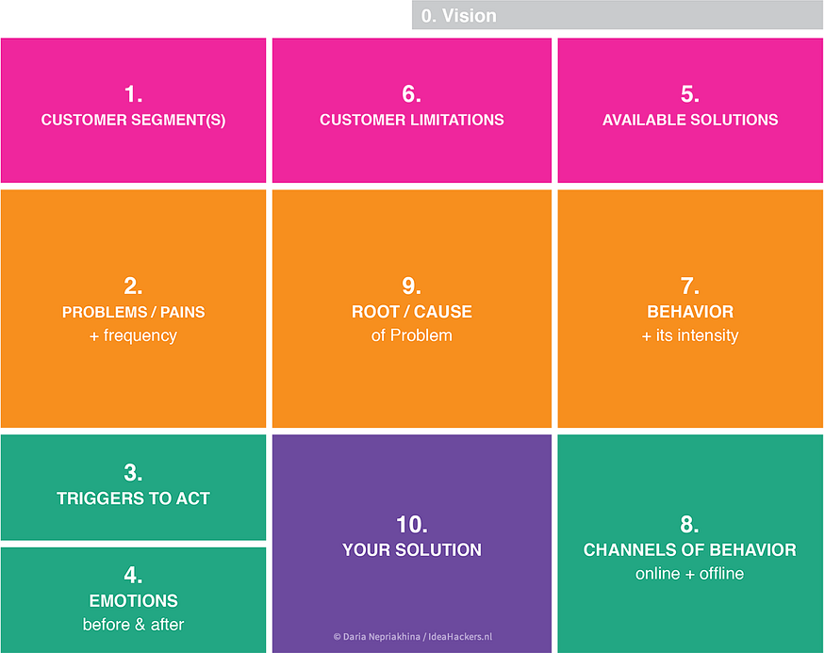

1. **Customer State fit:** to make sure you understand your target group, their limitations and their currently available solutions, against which you are going to compete.
2. **Problem-Behavior fit:** to help you filter out the noise and identify the most urgent and frequent problems, understand the real reasons behind them and see which behavior supports it. Is this behavior weak or infrequent — is it a problem worth solving?
3. **Communication-Channel fit:**to helpyou sharpen your communication with strong triggers, emotional messaging and reaching customers via the right channels.
4. **Solution guess**: translate all the validated data you have gathered into a solution that fits the customer state and his/her limitations, solves a real problem and taps into the common behavior of your target group.